

**FOOT PARTS**

Ball of foot = Ap Kumchi

(Front Sole)

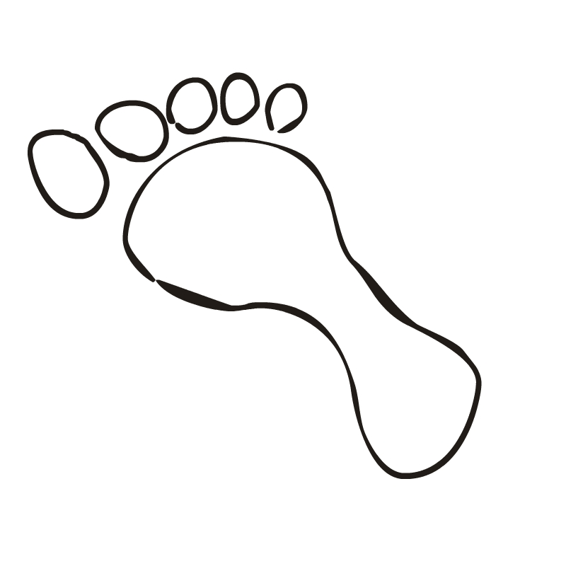 Toes = Balkut

Instep = Baldung

**Foot**

**Parts**

Footsword

(Blade of the foot)

Reverse/Inner Footsword = BalKal

(Arch of foot)

= Balkal Dung

Heel = Dwit Chook