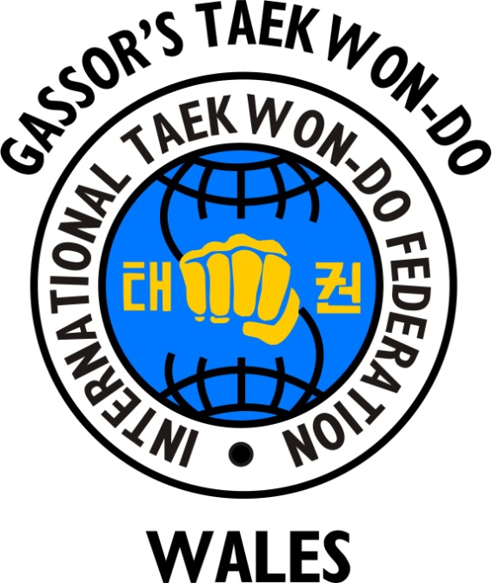
IMPORTANT
FIGURES IN TAEKWON-DO

- General Choi Hong Hi 9th Degree Black Belt =
Founder of Taekwon-Do

- First Grand Master Rhee Ki Ha 9th Degree Black Belt = Introduced Taekwon-Do into the UK in 1967

- Grand Master Choi Jung Hwa 9th Degree Black Belt = President of the ITF (International Taekwon-Do Federation) and son of the Founder General Choi Hong Hi

- Grand Master Trevor Nicholls 9th Degree Black Belt = President of the UK ITF, Vice-President of the ITF and Secretary General of the ITF

- Senior Master Gary Gassor 8th Degree Black Belt = Chief Instructor and Founder of IMAA (International Martial Arts Association), Gassor’s Taekwon-Do Wales and MAFC (Martial Arts and Fitness Centre). Chief International ITF Grading Examiner and Senior ITF Master.

- Mrs Leanne Gassor-Jones 5th Degree Black Belt = Senior International ITF Instructor and International Grading Examiner. Founder of Little Dragons Taekwon-Do. Head Coach and Founder of Gassor’s Tournament Team

