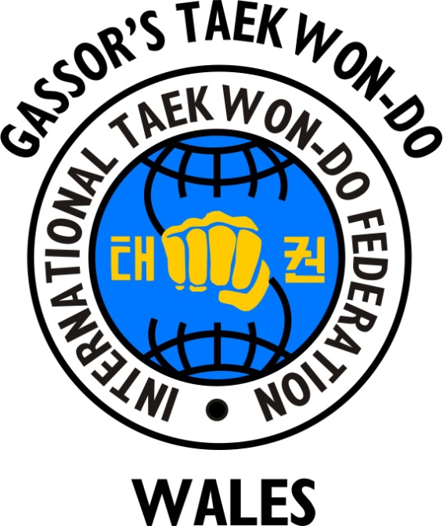
ORGANISATIONS

I.M.A.A. = International Martial Arts Association

M.A.F.C. = Martial Arts & Fitness Centre

I.T.F. = International Taekwon-Do Federation

U.K.I.T.F. = United Kingdom International
Taekwon-Do Federation

B.T.C. = British Taekwon-Do Council

W.T.F. = World Taekwon-Do Federation

N.A.K.M.A.S. = National Association of Karate &
Martial Arts Schools

