FOOT PARTS

Ball of foot =

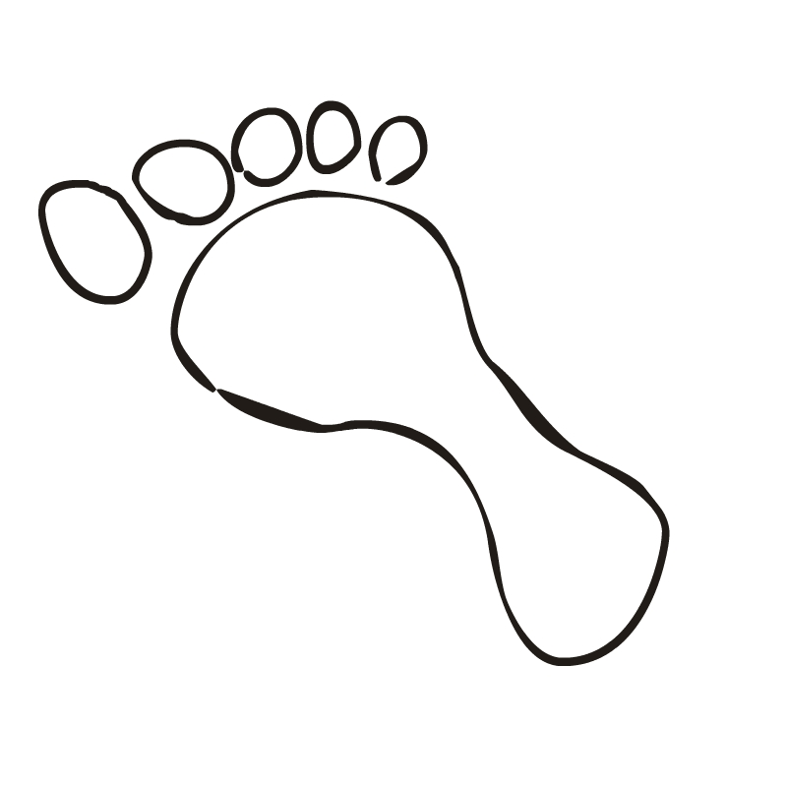
Toes =

Instep =
Foot
Parts

Footsword
(Blade of the foot)
Reverse/Inner Footsword =
(Arch of foot)
=

Heel =

