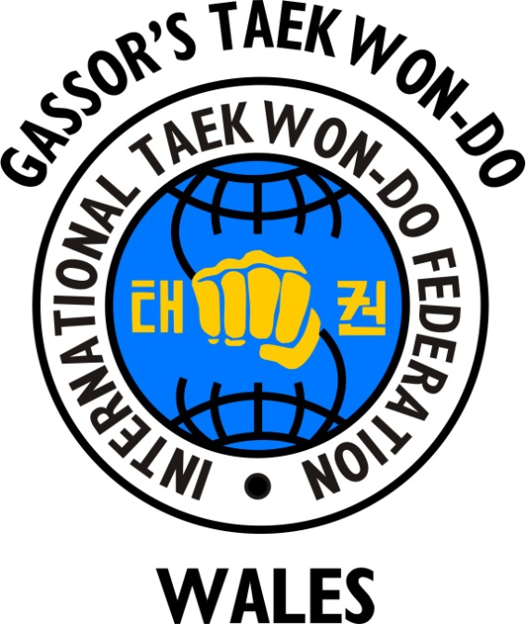
IMPORTANT
FIGURES IN TAEKWON-DO

- Who is the Founder of Taekwon-Do?

- Who introduced Taekwon-Do into the UK in 1967?

- Who is the President of the ITF (International Taekwon-Do Federation) and the son of the Founder General Choi Hong Hi?

- Who is the President of the UK ITF, Vice-President of the ITF and Secretary General of the ITF?

- Who is the Chief Instructor and Founder of the IMAA (International Martial Arts Association), Gassor’s Taekwon-Do Wales and MAFC (Martial Arts and Fitness Centre), Chief International ITF Grading Examiner and Senior ITF Master?

- Who is a Senior International ITF Instructor and International Grading Examiner, Founder of Little Dragons Taekwon-Do and the Head Coach and Founder of Gassor’s Tournament Team?

